7 Binomial Distribution

Objectives:
Understand the conditions necessary for a random variable to have a binomial distribution
Calculate probabilities for a binomial distribution
Learn the parameters of a binomial distribution
Understand how to approximate a real-world scenario as a binomial distribution

Content | Teacher's Activity | Student's Activity | Assignments
7.1 Binomial Distribution | - Through an example, introduce the terms related to a binomial distribution: number of trials (n), success/failure at each trial, probability of success (p)/ failure (f) at each trial  - 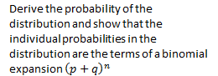  - 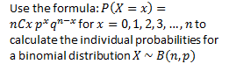 | - Understand the terms related to a binomial distribution  - 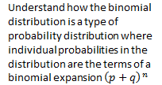  - 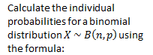  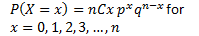 | Ex 7A
7.2 Using the binomial distribution as a model | - Explain the four properties that help identify a probability distribution as a binomial distribution [X ~ B(n, p) ]  - Through examples, determine if a given distribution is a binomial distribution  - Through examples, explain what assumptions need to be made in order for a given distribution to satisfy the conditions of a binomial distribution | - Given a distribution, verify if it satisfies the four conditions of a binomial distribution  - Given a situation, state the assumptions that need to be made in order to use the binomial distribution to model it | - Textbook Examples  - Ex 7B
Additional Practice | - Help students as required to solve the textbook problems | - Work out additional problems in the Misc Ex | - Misc Ex 7
Test |  |  | Clubbed with Probability Distribution

